Please note: Purple text throughout the document is meant to be instructional – and should not be included in the final proposal.
Note: The Cover Page does not count toward the page limit for the proposal.
Cover Page
Proposal Title: Please complete
Submitted by: Please insert name of Project Lead
Institution: Please complete
Affiliate/Partner Institution: Please complete
Address: Please complete
Phone: Please complete
Email: Please complete

Contact Table (Please complete. Add or delete rows as needed.)
Name | Role | Institution | Phone | Email
 | Project Lead
 | Co-lead
 | Co-lead
 | Financial Contact
 | Office of Sponsored Programs or Grants Office contact (or equivalent)

Proposed award period of performance: Please insert your preferred period of performance
Requested award amount: 2025 – 2026: $ XX
Proposed cost share: 2025 – 2026: $ XX

Note: The total page count for the following sections (Project description and merit, Alignment with NASA’s activities, interests, or programs, and Project management and timeline) should not exceed 5 pages.
Project description and merit:
Describe the proposed project and how it will engage Idaho’s students, educators, researchers, industry, and/or the public in NASA’s activities. If proposing a research project, the proposers should present the project proposal in plain language so that individuals who are not experts in the proposed research area will be able to effectively evaluate the research plan.

Alignment with NASA’s activities, interests, or programs
The proposal should demonstrate how the project aligns with NASA interests/activities and describe the benefits to ISGC, Idaho, NASA, and/or others. As much as possible, please identify the specific NASA program, activity, office, or NASA Center aligned with your project.

Project management and timeline:
The proposal should address how the project will be managed and staffed. This section should identify any possible challenges associated with the project’s implementation, and how the project will address those challenges. It should also include a project timeline that clearly indicates milestones and metrics to demonstrate progress.

Note: There is a 2 page limit for Project Lead CV/Resume and a 1 page limit for any Co-leads
CVs/Resume of Project Lead and Co-leads
Insert CVs/Resume for the Project Lead/P.I. and any Co-leads/Co-Is must be included.

Note: There is no page limit for the Budget Justification.
Budget Justification
The budget justification should align with the project proposal and explain the purpose of each expenditure and sources of cost share. The justification should align with the activities proposed in the budget and be consistent with the budget details.

Salaries
Describe any salaries or wages to be paid to personnel on the project.

Fringe Benefits
Describe any fringe benefits to be paid to personnel on the project.

Other Direct Costs - Subcontracts
Insert narrative here

Other Direct Costs – Consultants
Insert narrative here

Other Direct Costs – Supplies
Insert narrative here

Other Direct Costs - Travel
Insert narrative here

Other Direct Costs - Student fellowships and scholarships
Insert narrative here

Other Direct Costs - Publication and Dissemination
Insert narrative here

Total Direct Costs
Summarize the total direct costs for this project.

Modified Total Direct Costs
Summarize the Modified Total Direct Costs (MTDC). Often, MTDC consists of salaries and wages, fringe benefits, materials, supplies, services, travel, and sub-awards. However, these costs may vary by institution.

Indirect Costs
Summarize any indirect costs that your institution is charging on the project.

Grand Total
Summarize the total cost for the project.

Note: There is no page limit for the Budget Details
Budget Details
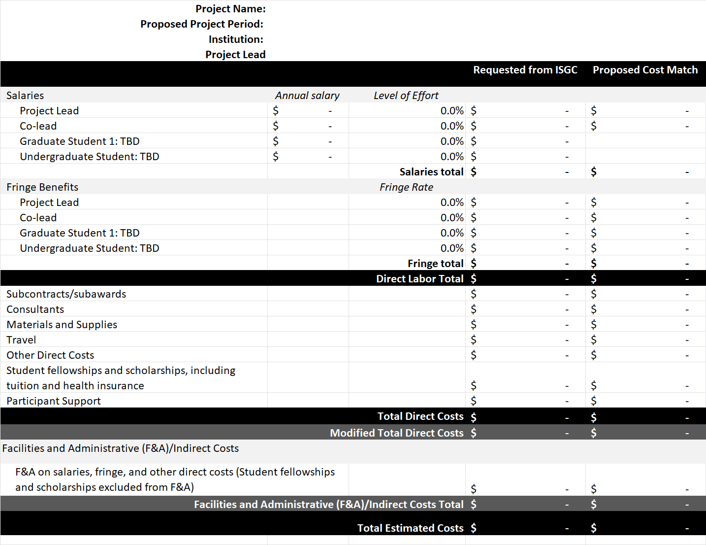
Cut and paste a copy of your MS Excel Budget table here

Note: There is no page limit for any letters related to the project.
OPTIONAL: Collaboration Letters/ Letters of Support/ Additional Support
While not required, if your team has collaborators from NASA, industry, an ISGC affiliate/partner, or other organizations, you may include information about the collaboration with your proposal. If you have received additional financial support, or anticipate any additional support for this project, include information such as the name of the funding agency, award amount, and the anticipated award date if not yet awarded.

Note: There is no page limit for any references and citations
OPTIONAL: References and Citations
Insert References and Citations.

Note: There is no page limit for the Summary of Past ISGC Awards
OPTIONAL: Summary of past ISGC award accomplishments
Proposers who have received previous NASA Idaho Space Grant funding for similar activities should submit a summary of accomplishments resulting from the award, including participants, goals achieved, proposals submitted, papers/presentations, or collaborations with NASA, the aerospace industry, or other partners in Idaho.

